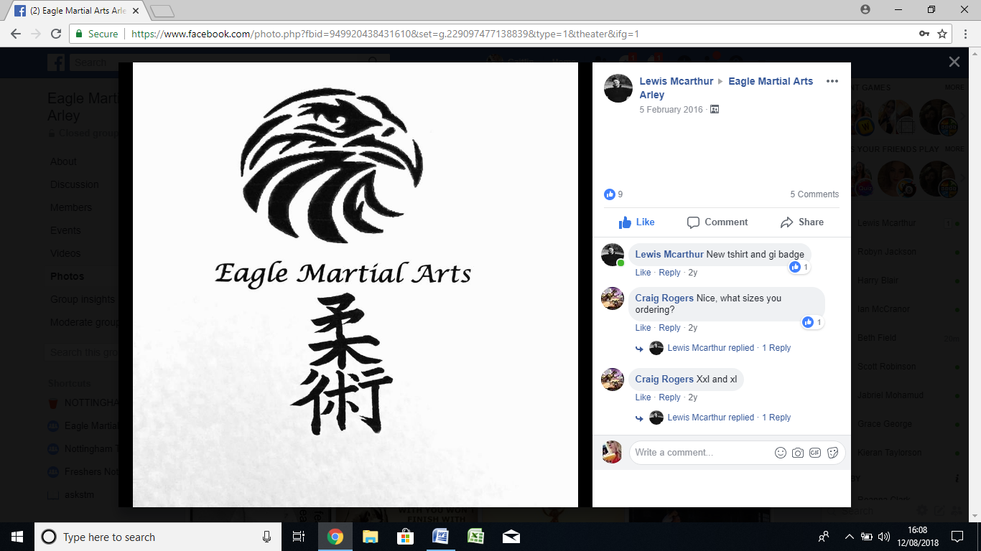

**The traditional Japanese Martial Art Ju-jutsu**

**Junior classes**

**Tuesday only 5 – 12 years 6 .30 - 7.30pm 12 - 18 years 7.45 - 9pm**

Adut A

**Martial Arts**

**General fitness classes**

**Pad & Bag work**

**Sparring**

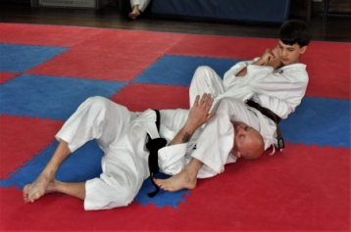

**For more information, contact Lewis on 07833575163 or eaglemartialarts@facebook.com**

**St John’s Hall Ansley Common**

**Nuneaton CV100PS**

**CV100QD**

**“The greatest victory is that which requires no battle.”**

**Sun tzu**

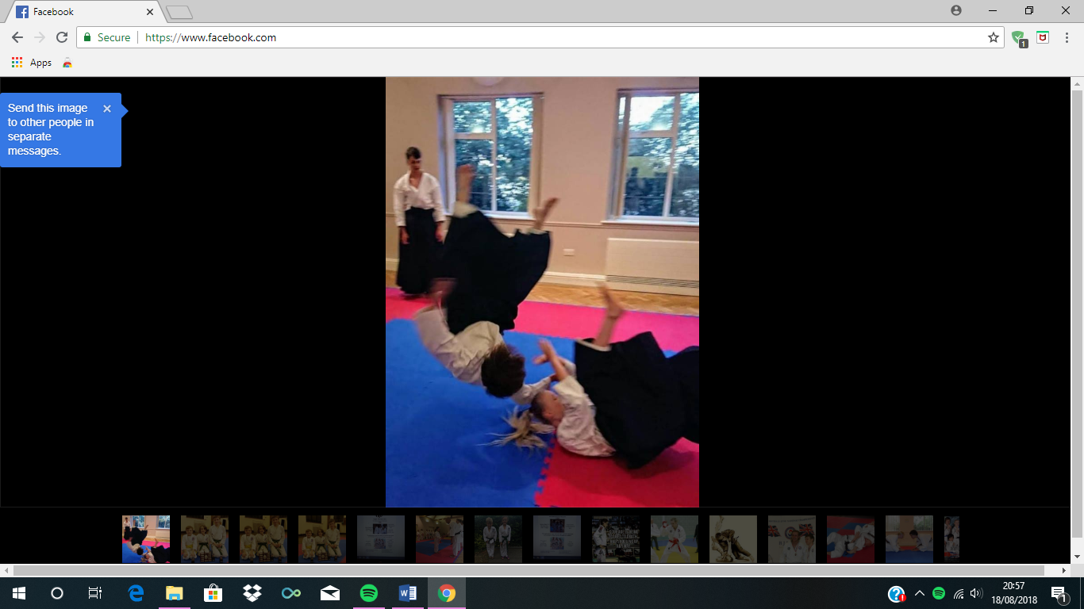

**Adults £5 per class + £20 per year**

**Juniors £3 per class + £12 per year**

**Adult**

**Classes**

**Sunday**

**5 – 6.30pm**